ADMISSION RELATED
QUESTION ANSWERING
SYSTEM


By
Khansa Safdar

Supervised By
Dr. Akmal Saeed Khattak

Department of Computer Science
Quaid-i-Azam University
Islamabad
(2020-2024)

ACKNOWLEDGEMENT

I would like to express my deepest gratitude to Allah Almighty for his blessings and giving me the strength to keep going throughout my academic tenure at Quaid-i-Azam university. I am deeply grateful to my project supervisor, Dr. Akmal Saeed Khattak for his invaluable guidance and support throughout my project.
I would also like to extend my sincere appreciation to all esteemed faculty members of the Computer Science Department, Dr. Rabeeh Ayaz Abbasi, Dr. Khalid Saleem, Dr. Muhammad Shuaib Karim, Dr. Onaiza Maqbool, Dr. Muazzam Ali Khan Khattak, Dr. Ayyaz Hussain, Dr. Mudassar Azam Sindhu, Dr. Ghazanfar Farooq Siddique, Dr. Umer Rashid and Mam Ifrah Farukh Khan for their continuous guidance and motivational support during my academic pursuits.
Lastly, my heartfelt thanks go to my family and friends for their unwavering love and support, which have been a constant source of motivation and inspiration for me.

ABSTRACT

This project is designed to help students and other people with the admission process of Quaid-i-Azam university. Rather than searching through websites or reading entire documents, it answers users queries quickly which can be time saving. It is an AI based system that uses NLP techniques to understand users’ questions related to admission and answer them accordingly. The purpose of this project is to offer attractive guidance to make applying to university easier by assisting them throughout the admission process. The data for this system is collected through crawling the university’s website targeting pages related to admission which is then preprocessed to create the knowledge base. The user queries are then processed, and the answer is retrieved by using techniques like TF-IDF and cosine similarity.
ACKNOWLEDGEMENT ………………………………………………………………………………………………………………..… i
Abstract ………………………………………………………………………………………………………………………………………..ii

Table of Contents
CHAPTER 1: Software Project Management Plan
1.1 Introduction 5
1.2 Applications 6
1.3 Existing systems 7
1.3.1 Georgia state university (GSU) 7
1.3.2 Ohio State University 8
1.3.3 Penn State University (PSU) 8
1.4 Project Organization 9
1.4.1 Process Model 9
1.4.2 Roles and Responsibilities 9
1.4.3 Tools and Techniques 9
1.4.4 Project deliverables 10
1.5 Project Management Plan 10
1.5.1 Tasks 10
1.5.2 Description 10
1.5.3 Project Plan 11
CHAPTER 2: Software Requirements Specification
2.1 Introduction 13
2.2 Admission Query Answering system 13
2.2.1 Purpose 13
2.2.2 Scope 13
2.3 Overall description 14
2.3.1 Product Perspective 14
2.3.2 Product Functions 14
2.3.3 User Characteristics 15
2.3.4 Constraints 15
2.3.5 Usecase list 15
2.3.6 Usecase Diagram 16
2.4 Specific Requirements 17
2.4.1 Usecase scenario 17
2.4.2 System Sequence Diagrams 25
2.4.3 Domain Model 30
CHAPTER 3: Software Design Description
3.1 Introduction 32
3.1.1 Design Overview 32
3.2 Requirements Traceability Matrix 32
3.3 Class Diagram 33
3.4 Sequence Diagrams 34
CHAPTER 4: Software Implementation
4.1 Introduction 37
4.2 Implementation 37
4.2.1 Frontend design 37
4.2.2 Backend design 37
4.2.3 Interface design 39

CHAPTER 5: Software Test Documentation
5.1 Introduction 41
5.1.1 System Overview 41
5.1.2 Test Approach 41
5.2 Test Plan 41
5.2.1 Features to be tested 41
5.3 Test Cases 41
CHAPTER 6: Conclusion
6.1 Conclusion 46
6.2 Future Work 46
References: 47

Table of Figures
Figure 1.1: Google Search 5
Figure 1.2: Georgia State university QA system named pounce………………………………………………………....6
Figure 1.3: Before a question is asked………………………………………………………………………………………………..7
Figure 1.4: After a question is asked………………………………………………………………………………………………...…7
Figure 1.5: Interface of BuckeyeBot……………………………………………………………………………………………….…..8
Figure 1.6: Before a question is asked…………………………………………………………………………………………….....8
Figure 1.7: After a question is asked……………………………………………………………………………………………….....8
Figure 1.8: Agile model………………………………………………………………………………………………………………….…..9
Figure 1.9: Project Plan…………………………………………………………………………………………………………………....11
Figure 2.1: Usecase diagram 16
Figure 2.2: Login……………………………………………………………………………………………………………………………...25
Figure 2.3: Ask question…………………………………………………………………………………………………………………..25
Figure 2.4: Provide Feedback …………………………………………………………………………………………………………..26
Figure 2.5: View Questions……………………………………………………………………………………………………………...26
Figure 2.6: Update courses…………………………………………………………………………………………………………..…27
Figure 2.7: Add courses……………………………………………………………………………………………………………………27
Figure 2.8: Delete courses……………………………………………………………………………………………………………….28
Figure 2.9: Update fees……………………………………………………………………………………………………………..…….28
Figure 2.10: View courses………………………………………………………………………………………………………………..29
Figure 2.11: View fees…………………………………………………………………………………………………………………..…29
Figure 2.12: Domain model………………………………………………………………………………………………………..……30
Figure 3.1: Class diagram………………………………………………………………………………………………………………….33
Figure 3.2: Ask questions and provide feedback……………………………………………………………………..……….34
Figure 3.3: Add courses……………………………………………………………………………………………………………………34
Figure 3.4: Update fees……………………………………………………………………………………………………………………35

CHAPTER 1:
SOFTWARE PROJECT MANAGEMENT PLAN
(SPMP)
ADMISSION RELATED QUESTION ANSWERING SYSTEM:

1.1 Introduction
In today’s world we often need answers to our questions quickly. A question answering system provided a platform for such users where they can get accurate answers instantly. It is like having a smart assistant inside your computer. The computer uses your word choice to determine what you are asking when you ask a question. After that, it looks for information online or in its database to see if it can address your query. When it has the solution, the computer shows it to you in an understandable format.
It is an AI-based system that is used to automatically respond to questions of users in natural language. The search engines that are widely used are also an example of QA system, but they do not provide the exact and precise answer to the user queries in fact they provide a list of documents that might or might not contain the exact answer. The user must read the entire document to check if it contains the required answer or not. This can be time taking so the main goal of this system is to generate accurate answers to the queries of the users using information retrieval and Natural language processing (NLP) instead of reading the entire documents. It is capable of handling questions asked in natural language. There are different types of QA systems:
A closed domain QA system answers questions under a specific domain e.g. medicine, law, education as shown in figure 1.2 etc. whereas
An open domain QA system can answer nearly every question related to every domain so the accuracy can be very low e.g. google search as shown in figure 1.1.
Some examples of question answering systems are:
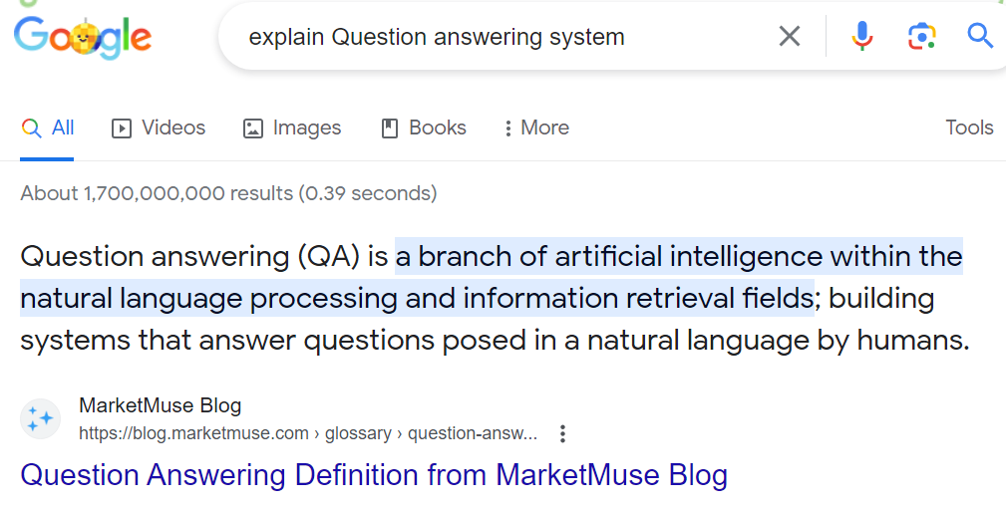

Figure 1.1: Google Search

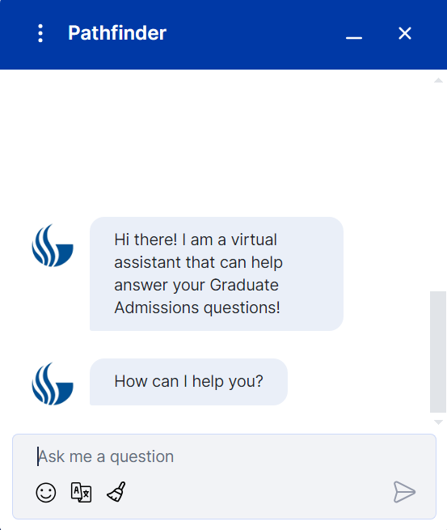

Figure 1.2: Georgia State university QA system named pounce

A QA system is different from a dialogue box and chatbot as QA system focuses on generating accurate information by retrieving information from the knowledge base. It is usually a one-way interaction where the user gives a question as an input and the system outputs the answer. A dialogue box is a window in the GUI which displays information to the user and prompts them for response for example file save confirmation dialogue. If the user tries to close the file without saving the changes the dialogue box pops up to confirm if the user wants to save the changes hence it is a two-way interaction whereas a chatbot uses generative AI and can maintain a conversation with a human in natural language. It is also a two-way interaction and allows humans to have a conversation with the system as if they are communicating with another human.

1.2 Applications
QA systems can be used in different domains and variety of applications to provide answers to users queries in real time for example for educational systems to help students, parents, and other stakeholders and answer their queries related to admission, campus life, registration, and other related topics. In healthcare systems it is used to help patients as well as doctors providing information about symptoms, treatment etc. It can also be used in legal research to help legal professionals and other people to retrieve information about a case, so it can be used in almost every application. There are many QA systems that are currently used. In the next section we will see some of the existing admission related QA systems used by different universities.

1.3 Existing systems
There are different QA systems, each has its own purpose. Each one is built using different techniques. In case of education related QA systems many universities and schools have integrated QA systems on their websites to help students by answering their queries. Here is a list of some of these universities:

- Georgia state university.
(https://graduate.gsu.edu/landing-parent/mph-ad-landingpage/?utm_source=nwdigital&utm_medium=ppc&utm_campaign=mph&utm_term=googlepmax&utm_content=general&gad_source=1&gclid=Cj0KCQiAz8GuBhCxARIsAOpzk8xZthIquc1dH37yEHEu4A1PVv43yixX4fuh3dBWopITxsBdaQMAHP8aAhtvEALw_wcB)
- Ohio State University (https://undergrad.osu.edu/)
- Penn State University (https://www.registrar.psu.edu/)

1.3.1 Georgia state university (GSU)
"Pounce" is a QA system that GSU set up to help students with inquiries about registration, financial assistance, admissions, campus services, and more. Figure 1.3 and Figure 1.4 shows the interface of the system before and after a question is asked respectively.
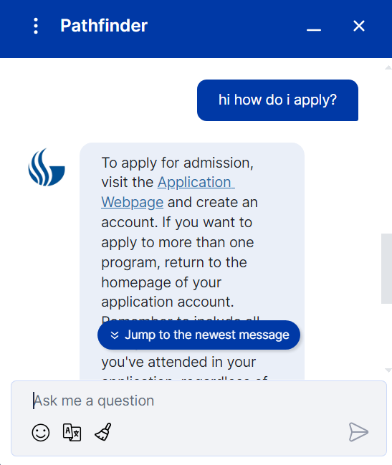


Figure 1.4: After a question is asked.
Figure 1.3: Before a question is asked.

1.3.2 Ohio State University
"BuckeyeBot" is a virtual assistant that OSU offers to assist students with questions about financial assistance, registration, admissions, campus services, and other topics. Interface of the system is shown in figure 1.5.
Figure 1.5: Interface of BuckeyeBot

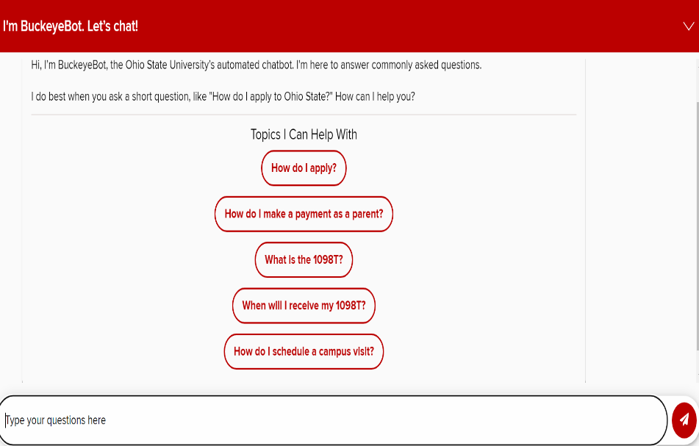

1.3.3 Penn State University (PSU)
Penn State university developed a QA system called “Ask Lion” on their website. Students can get assistance from it with inquiries on academic programmes, financial aid, enrollment, admissions, and student support services. Figure 1.6 and Figure 1.7 shows the interface of the system before and after a question is asked respectively.

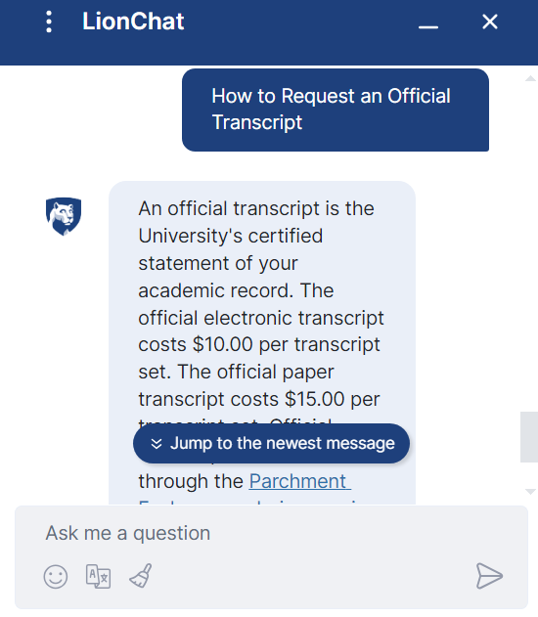
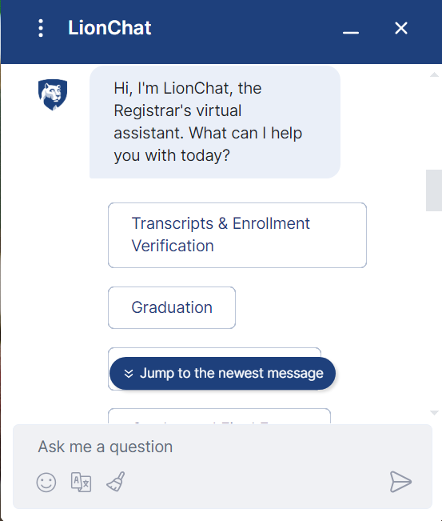
Figure 1.7: After a question is asked.

Figure 1.7: After a question is asked.
Figure 1.6: Before a question is asked.

Figure 1.6: Before a question is asked.

1.4 Project Organization

1.4.1 Process Model
The process model that I will follow is Agile methodology because it is ideal for projects that require adaptability. In this project will have meetings with the client from time to time which ensures that the project aligns with the client’s requirements. It uses short iterative development cycles, or sprints, in which features are produced incrementally. Continuous feedback and modification are made possible by this paradigm, which can help to improve the system in response to changing user demands and requirements. So, this model ensures adaptability and scalability. Figure 1.8 shows the stages of the agile model.
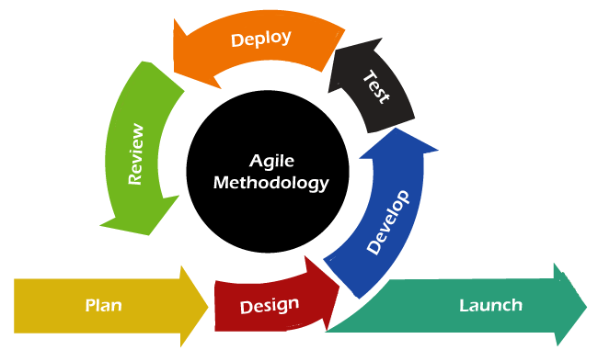
Figure 1.8: Agile model

1.4.2 Roles and Responsibilities
Roles:
My role is to develop a question answering system for my university that will help the students as well as the parents with queries about the admission process of the university and my supervisor will guide me about the working of the system.

Responsibilities:
The responsibilities include :
- Understanding of the requirements of the project.
- Understand the workflow of the project by coordinating with the supervisor.

1.4.3 Tools and Techniques
- Project libre
- MS word
- Draw.io
- Visual studio code
- MongoDB
- Python

1.4.4 Project deliverables
- Software Project Management Plan (SPMP).
- Software Requirement Specification (SRS).
- Software Design Description (SDD).
- Software Test Documentation (STD).
- The web application.

1.5 Project Management Plan

1.5.1 Tasks
The project plan is divided into different phases:
- The requirement or analysis phase.
- The design phase.
- The Development phase.
- The testing phase.

1.5.2 Description
The first phase is the requirement and analysis phase which includes the gathering and analysis of the requirements. After understanding the needs of the user, the scope of the project is defined. Other tasks include defining constraints, methodology, developing usecases and the SRS. The next phase is the design phase in which the overall structure and architecture of the system is planned. The development phase includes the implementation of the system based on the architecture defined in the previous phase. Lastly, the testing phase includes the testing of the software to identify and fix the bugs and errors.

1.5.3 Project Plan
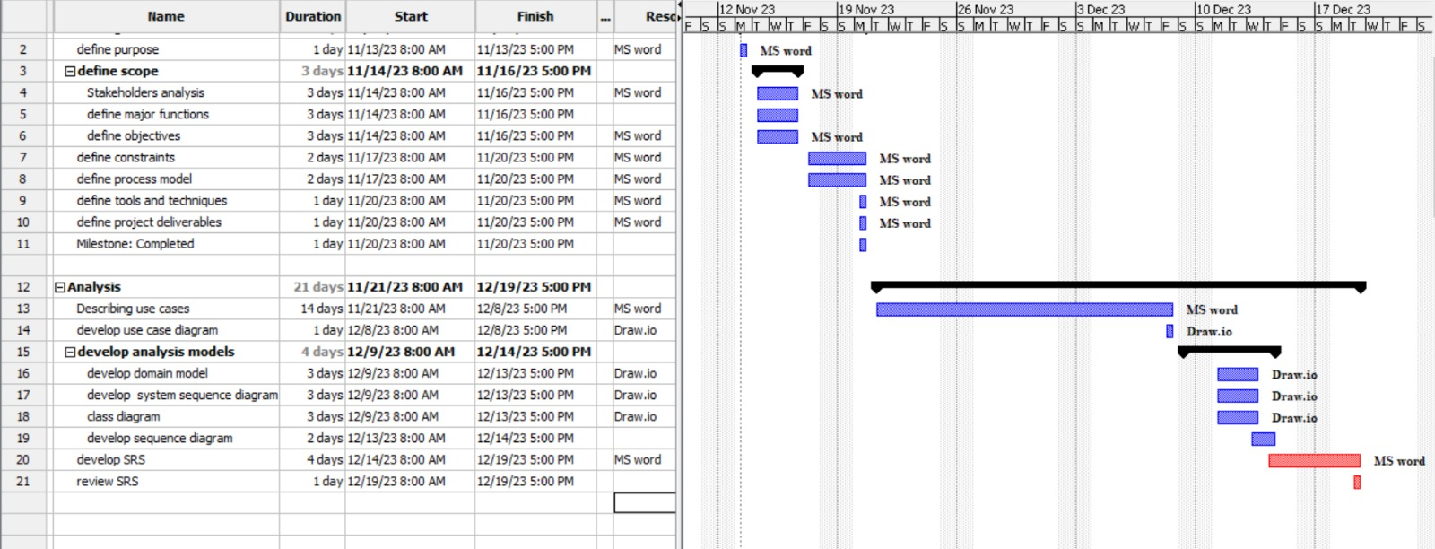
Figure 1.9: Project Plan

CHAPTER 2:
SOFTWARE REQUIREMENT SPECIFICATION
(SRS)

2.1 Introduction
In this chapter we will define the scope and objectives of the system. We will also develop the usecases and the UML diagrams.

2.2 Admission Query Answering system

2.2.1 Purpose
Our admission query answering system is a closed domain system as it is restricted to queries related to the admission process of our university only. The system is majorly designed to answer the questions or queries of students, parents, or other users related to admission procedures, courses offered, fees, the documents required, eligibility criteria and some other details. The goal of system is to improve the overall experience for potential students and expedite the admissions process by providing a user-friendly interface for asking questions and getting prompt answers which is also time saving. These systems eventually give people the power to make educated decisions about their futures in education by reducing misunderstanding, addressing frequent concerns, and offering clarification on a variety of admissions-related issues.

2.2.2 Scope

Stakeholders:
- Prospective students
- Current students
- Administrative staff
- Parents and guardians

Functionalities:
- Accept and process user queries related to admission process.
- Retrieves information from the knowledge base and displays answers to the user.
- Users can browse to the web page to get more details.
- Users can give feedback to the answer generated by the system.
- Admin can view the questions.
- Admin can also add, update or delete the courses displayed on the website.
- Admin can also update the fees of different programs on the website.

Objectives:
Other information retrieval systems provide documents in return of the question and the user must read the entire document to find the answer about the university admission which can be time consuming, so the purpose of this system is:
- Accurate answers:
The system makes it easier for users to access accurate information and generate answers regarding the admissions process.

- Real time engagement:
It allows users to interact with the system and receive answers in real time which can enhance the user experience.

- Efficiency and Time saving:
Quickens the information gathering process for admissions, saving time for both administrative workers and candidates.

- Availability:
The system should be available all the time, making it easier for the user to retrieve information at any time.

2.3 Overall description

2.3.1 Product Perspective
The education related question answering system is standalone and is not a part of any larger system. When the user asks the question, it understands and responds to the question on its own. There is no need of any other system for this task.

2.3.2 Product Functions
The purpose of this QA system is to answer user queries related to the admission process. First relevant pages are crawled from QAU,s website and stored in a structured format. Then the irrelevant information is removed, and the inverted index is created to map each word with its location in each document. The user asks a question, the question is processes and keywords are generated, and the most relevant piece of information is extracted from the documents. The user can give feedback to the response generated by the system. The admin can login to the system and can view the list of questions asked by different users. The admin can also add, update or delete the courses and update the fee of different programs that are displayed on the website. The user can also browse the website and can view the courses and fee from the website.

2.3.3 User Characteristics
The users of the system are students, parents or any other individuals that have queries related to the admission process of the university and administrator who can view their queries. For this system the user must have some knowledge and experience of computer systems so that they can easily interact with the system.

2.3.4 Constraints
There are different constraints:
- The computer or laptop must have internet connectivity.
- The website should be responsive. It should work for all screen sizes.

2.3.5 Usecase list
- Login.
- Ask questions.
- Provide feedback.
- View questions.
- Update courses.
- Add courses.
- Delete courses.
- Update fees.
- View courses.
- View fees.

2.3.6 Usecase Diagram
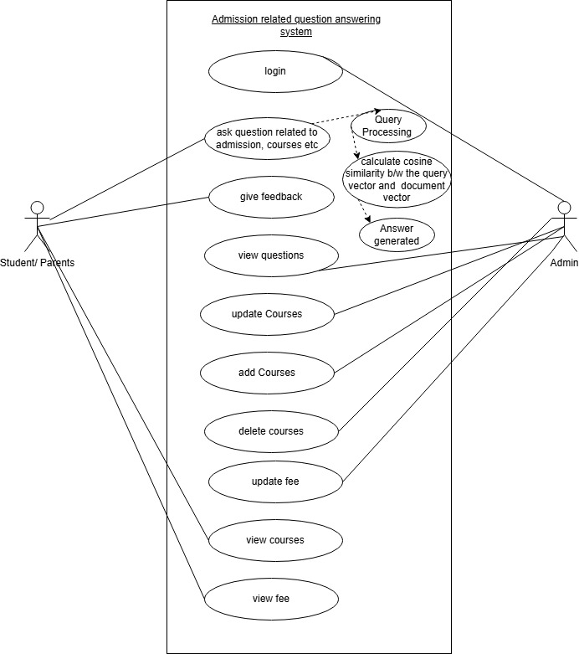

Figure 2.1: Usecase diagram

The main focus of this software is the question answering system which answers the queries of the user related to the admission process. In this system the user can ask a question and the system generates a response from the relevant document. The admin can view these questions and the feedback to analyze the system. The user can also provide feedback. In addition to this we will also provide a website so that the user can browse and find the information. The admin can login to the system and can add or delete the courses and update the fees of different programs that are being displayed on the website.

2.4 Specific Requirements

2.4.1 Usecase scenario

UC1: login
Purpose | Admin can login to his id
Actor | Administrator
Input data | id and password
Output data | Corresponding interface
Pre-conditions | profile must exist already , id and password should be correct
Post- conditions | Profile will be logged in
procedure | The data that admin entered will be validated and user interface will be displayed
Alternative | In case of Invalid password, invalid username, or mismatched username and password , error message will be displayed and redirect to previous page.

UC 2: Ask question:
Purpose | User can ask a question.
User | User
Input data | The content of the question
Output data | Response generated by the system
Pre-conditions | User must open the QA system interface from the website
Post- conditions | - The question is stored in the database.  - The user gets the response to the question.
procedure | - The user opens the QA system from the website.  - User enters the query.  - User submits the question.  - The system displays the question on the interface.  - The system processes the question, generated keywords, calculate cosine similarity and gives answer from the document that is ranked highest.  - The response is displayed on the interface.  - The question is stored in the database.
Alternative | - If the question asked is invalid, the system generates the message to ask relevant questions.  - If the network is slow or there is some error in processing the question, the systems displays the error message.

UC 3: Provide feedback:
Purpose | User can provide feedback to the responses generated by the system.
User | User
Input data | The feedback by the user
Output data | None
Pre-conditions | User has asked the question, and the response is generated by the system.
Post- conditions | User’s feedback is saved in the database.
procedure | - The system generates a response to the user’s query and the user views the response.  - The system displayed an option for feedback(like or dislike)  - User selects the suitable feedback according to the response.  - The feedback is saved in the database.
Alternative | - If there is an error in providing the feedback, the system displays the error message.

UC 4: View questions:
Purpose | Admin can view the list of questions asked by the user.
User | Administrator
Input data | None
Output data | List of questions.
Pre-conditions | Admin is logged in.
Post- conditions | Admin can traverse through the list of questions.
procedure | - Admin selects the view questions option from the interface.  - The system retrieves all the questions stored in the database.  - The system displays the list of questions.  - Admin can traverse through the list of questions.
Alternative | - If there is an error in retrieving the questions from the database, the system displays the error message.  - If there are no questions available in the database, the system displays the relevant message.

UC 6: Update courses:
Purpose | Admin can Update courses that are displayed on the website.
User | Administrator
Input data | course details including the name of the course, description etc.
Output data | Confirmation message that the course is added successfully.
Pre-conditions | Admin is logged in
Post- conditions | The course is updated and is displayed on the website.
procedure | - The admin selects the Update courses option from the interface.  - Admin selects the program.  - Admin enters the course details like name, description etc.  - Admin clicks the submit button.  - The system checks if the information is valid.  - If the information is valid, it successfully stores the course to the database.  - The system updates the list of courses displayed on the website.  - Admin receives the confirmation message that the course is added successfully.
Alternative | - If the information entered in invalid or if there are missing fields, the system displays the error message.  - While adding the courses if there are some issues like database connectivity, the system displays an error message to the admin.

UC 6: Add courses:
Purpose | Admin can add courses that are displayed on the website.
User | Administrator
Input data | course details including the name of the course, description etc.
Output data | Confirmation message that the course is added successfully.
Pre-conditions | Admin is logged in
Post- conditions | The course is added and is displayed on the website.
procedure | - 1The admin selects the add courses option from the interface.  - Admin selects the program.  - Admin enters the course details like name, description etc.  - Admin clicks the submit button.  - The system checks if the information is valid.  - If the information is valid, it successfully stores the course to the database.  - The system updates the list of courses displayed on the website.  - Admin receives the confirmation message that the course is added successfully.
Alternative | - If the information entered in invalid or if there are missing fields, the system displays the error message.  - While adding the courses if there are some issues like database connectivity, the system displays an error message to the admin.

UC 7: Delete courses:
Purpose | Admin can delete courses from the list displayed on the website.
User | Administrator
Input data | Course to be deleted
Output data | The confirmation message received after the course is deleted successfully.
Pre-conditions | Admin is logged in.
Post- conditions | The course is deleted and list of courses is updated.
procedure | - Admin selects the delete course option from the interface.  - Admin selects the course to be deleted from the list of courses.  - Admin clicks on the delete button.  - The system confirms deletion action.  - After the confirmation, the system removes the course from the database.  - The system updates the list of courses displayed on the website.  - Admin receives the confirmation message that the course is deleted successfully.
Alternative | While deleting the courses if there are some issues like database connectivity, the system displays an error message to the admin.

UC 8: Update fee:
Purpose | Admin can update the fee for different programs like BS, MPhil, PHD etc.
User | Administrator
Input data | - Program type.  - New amount.
Output data | Confirmation message that the fees is updated successfully.
Pre-conditions | Admin is logged in.
Post- conditions | Fee for that specific program is updated.
procedure | - Admin selects the update fee option from the interface.  - Admin selects the academic program (BS, MPhil, PHD)  - Admin enters the new amount.  - Admin clicks the update button.  - The system validates the new amount.  - If the validation is successful, the system updates it in the database.  - The system updates the fee on the website.  - Admin receives the confirmation message that the fees is updated successfully.
Alternative | - If the user enters the wrong amount e.g negative the systems displays an error message and prompts the user to enter the right amount.  - While updating the fees if there are some issues like database connectivity, the system displays an error message to the admin.

UC 9: View courses:
Purpose | User can view the courses displayed on the website.
User | User
Input data | None
Output data | List of courses displayed on the website.
Pre-conditions | - User opens the website.  - The courses are displayed on the website.
Post- conditions | User has successfully viewed the courses from the website.
procedure | - The user browses through the website.  - User visits the section that displays the list of courses.  - The system retrieves the courses from the database and displays them.  - The user can traverse through the list and courses and view the information.  - The user can browse the rest of the website.
Alternative | - If there are no courses available in the database, the system displays the relevant message.  - While displaying the courses if there are some technical issues, the system displays an error message to the admin.

UC 10: View fee:
Purpose | The user can view the fees for different programs on the website.
User | User
Input data | None
Output data | Fees for the specified program displayed on the website.
Pre-conditions | - The user opens the website.  - The fees for programs are displayed on the website
Post- conditions | User has successfully viewed the fees for the specific program on the website.
procedure | - The user browses through the website.  - User visits the section that displays the fees for different programs.  - The system retrieves the fees for different programs from the database and displays them.  - The user can browse the rest of the website.
Alternative | - If there are no courses available in the database, the system displays the relevant message.  - While displaying the courses if there are some technical issues, the system displays an error message to the admin.

2.4.2 System Sequence Diagrams

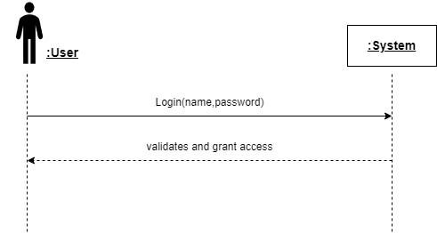
Login:
Figure 2.2: Login

Ask Question:

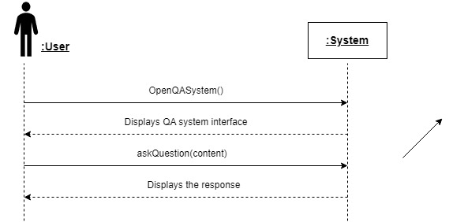

Figure 2.3: Ask question

Provide feedback:
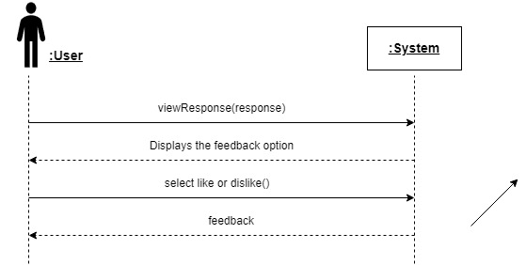
Figure 2.4: Provide feedback

View Questions:
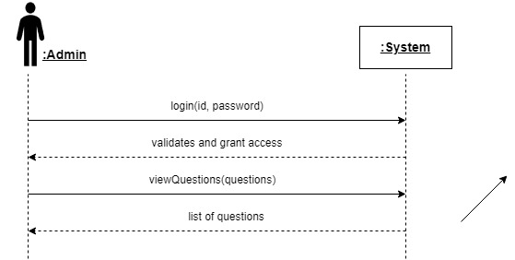
Figure 2.5: View Questions

Update courses:

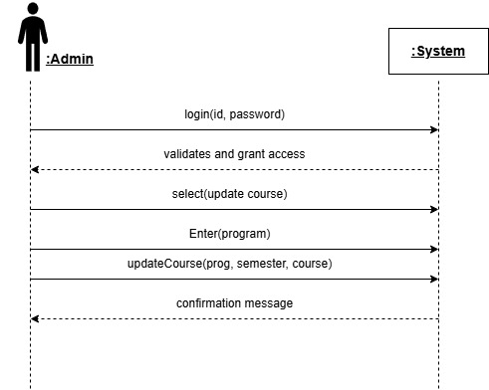

Figure 2.6: Update courses

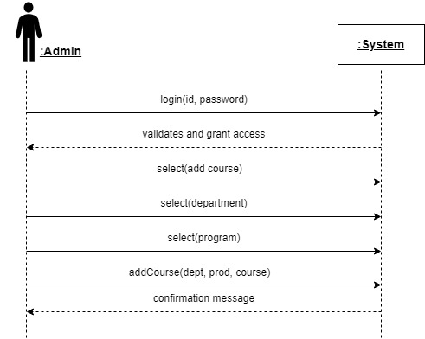
Add courses:
Figure 2.7: Add courses
Delete course:
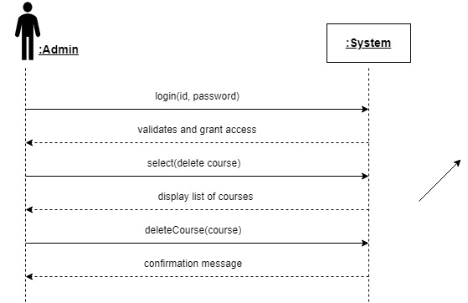
Figure 2.8: Delete Courses
Update fees:
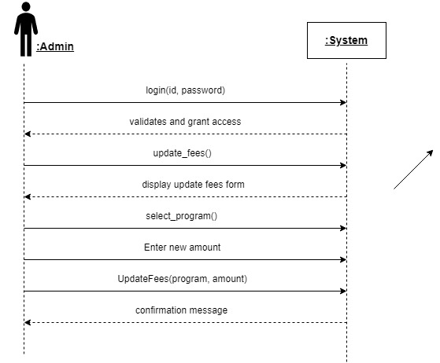

Figure 2.9: Update fees

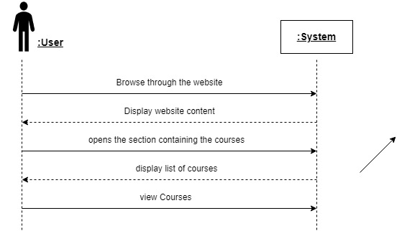
View courses:
Figure 2.10: View Courses

View fees:
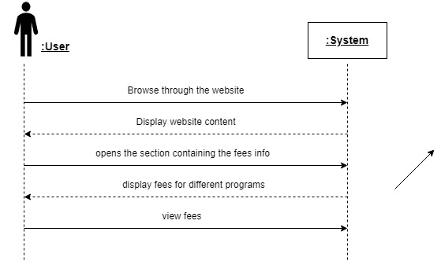
Figure 2.11: View Fees

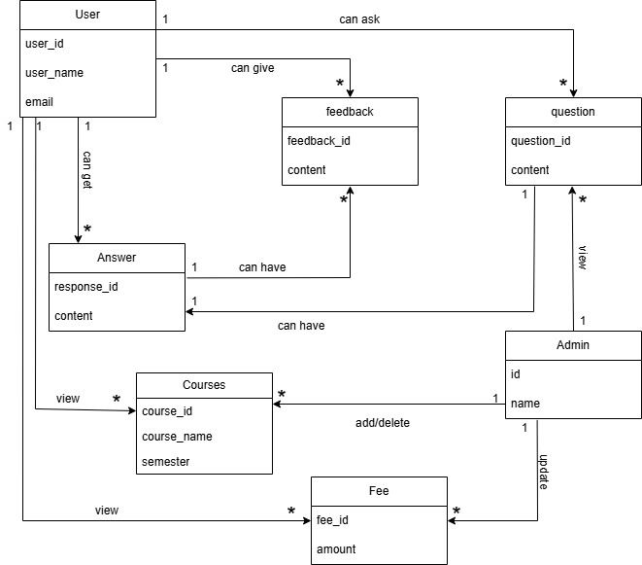
2.4.3 Domain Model
Figure 2.12: Domain Model

CHAPTER 3:
SOFTWARE DESIGN DESCRIPTION
(SDD)

3.1 Introduction
This chapter includes the design of the system, what it does and how it fulfills the requirements of the user. It also includes the class diagram and the sequence diagram to show how the system works.

3.1.1 Design Overview
The SDD explains how our system is designed. There are many components, it breaks down these components to show how they work together and answer the questions of the user.

3.2 Requirements Traceability Matrix
The requirement traceability matrix (RTM) is a tool for software objects that keeps track of the requirements from the start to the end until they are fully developed and tested.

Requirement ID | Requirement name | Interface | Test case
UC-1 | Login | Login form | Test the user login process
UC-2 | Ask question | QA system interface | Test the submission of the question
UC-3 | Provide feedback | QA system interface | Test the submission of the feedback
UC-4 | View questions | Page for viewing questions. | Test admin question viewing.
UC-5 | Update courses | Form for course addition | Test admins course update process
UC-6 | Add courses | Form for course addition | Test admin course addition
UC-7 | Delete courses | feature for course deletion | Test admin course deletion
UC-8 | Update fees | Form to update fees | Test admins fee update process
UC-9 | View courses | Website | Test users course viewing on the website
UC-10 | View fees | Website | Test users fee viewing on the website

3.3 Class Diagram
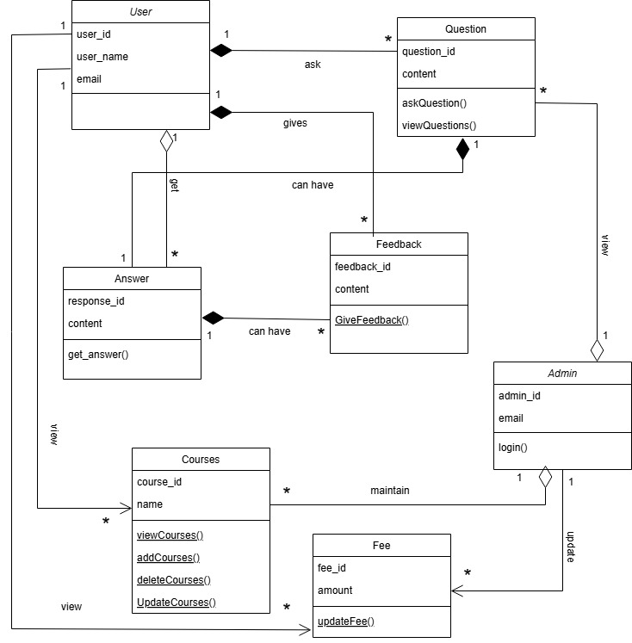
Figure 3.1: Class Diagram

The figure 3.1 shows a class diagram of the system. Is contains different classes and have different relations between them like a user can ask many questions so it contains one-to-many relation. A user can also give many feedback or a user can view many courses so it also has one-to-many relationship. The administrator can add or delete many courses, so it also has one-to-many relationship.

3.4 Sequence Diagrams

Ask question and provide feedback:
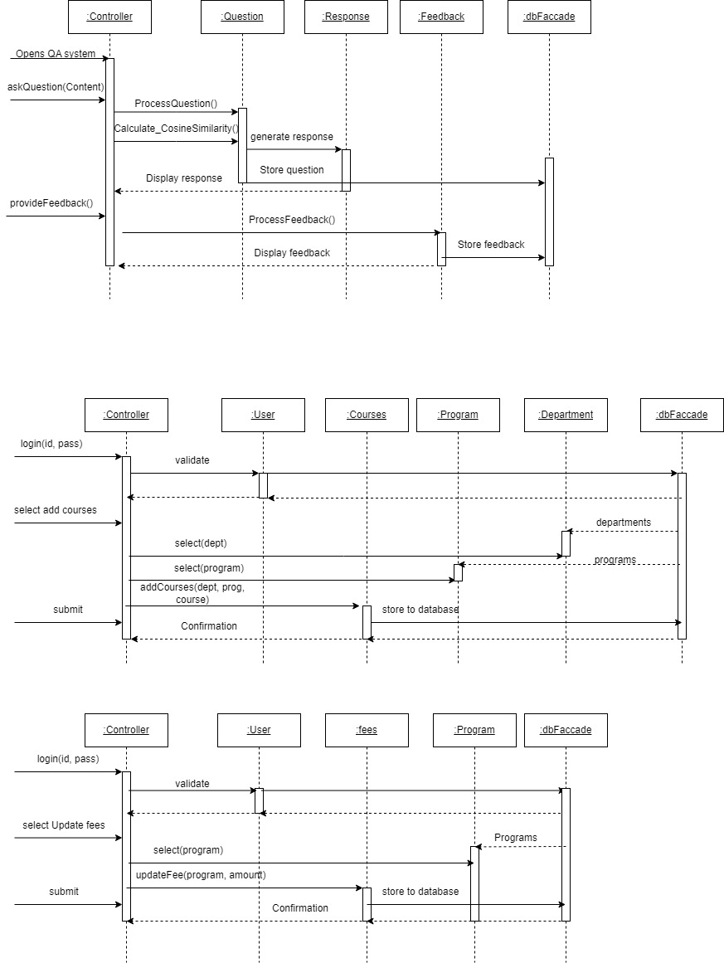
Figure 3.2: Ask question and provide feedback

Add courses:
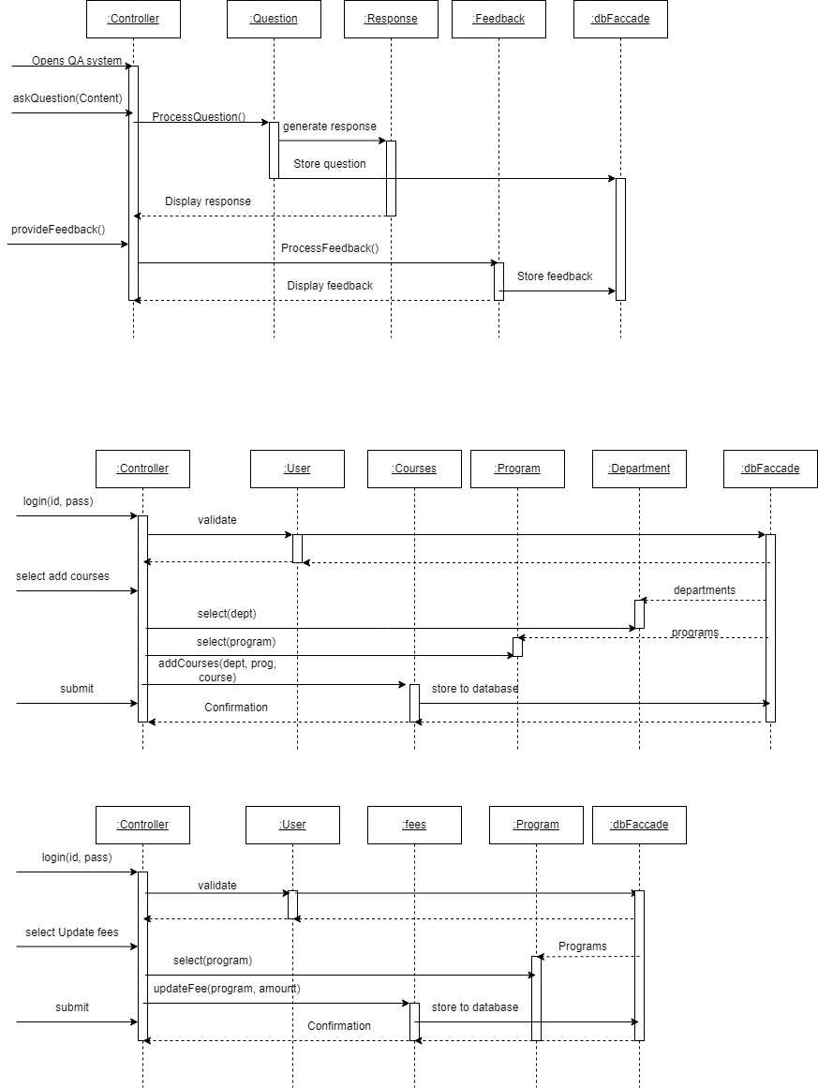
Figure 3.3: Add courses


Update fees:
Figure 3.4: Update fee

CHAPTER 4:
SOFTWARE
IMPLEMENTATION

4.1 Introduction
This chapter provides a detailed overview of the implementation of the Question Answering System that is developed to address the queries of the users related to the admission process of the Quaid-i-Azam University. The focus will be on the technical process about how the data was collected and preprocessed using the Natural Language Processing techniques.

4.2 Implementation
This QA System is an Admission related Question Answering system for Quaid-i-Azam University. It is designed to answer queries of the user related to the admission process, courses offered, eligibility criteria, fee structure etc. It crawls the relevant Pages from the university’s website to gather the data. The user asks the question in natural language and the system provides the relevant information from the data gathered. This simplifies the process of accessing the information then scrolling the entire website, hence saving time and enhancing the user’s experience. The implementation of this project is done in python.

Frontend design
This is a QA system for the university, so we have to build the university website using MERN stack. The home page of the website will contain the QA system developed using React.

Backend design

- Web crawling and Data Cleaning:
We used python libraries (requests and beautifulSoup) to extract relevant pages and data from the QAU’s website and then cleaned the extracted text by removing unnecessary HTML tags, special characters and extra white spaces.

- Categorization:
After cleaning of data, we categorized the pages based on the URL and the text e.g. admission, courses, fee. This categorization helps in efficient retrieval of relevant answers.

- Inverted Index:
After that we performed tokenization, removed stop words and then stem or lemmatize words to their root form. Then we created the meta file containing the keywords, category, URL and id of each page. Then the final step is to create the inverted index that maps each word to the page id and the frequency of a word in each page.

- Word Embedding:
To enhance the accuracy of matching user queries with relevant pages, we implemented word embedding using a pre-trained Word2Vec model. Word embeddings convert words into numerical vector representations, capturing their semantic relationships. This allows our system to go beyond exact keyword matching by understanding the contextual similarity between words.

- Question Processing:
When the user asks a question, it is also preprocessed to extract keywords. After that the cosine similarity is calculated against each document to rank each page and the answer is extracted from the page that is ranked the highest.
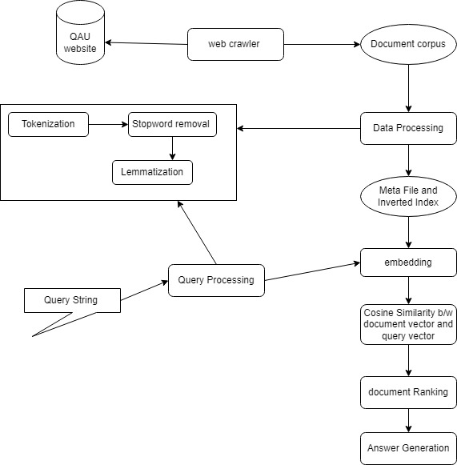



- Accuracy:
To evaluate the system's performance, we used a dataset containing user questions and their corresponding correct answers (ground truth). The system processed each question and generated answers, which were compared to the ground truth to determine correctness. Key metrics such as accuracy, precision, recall, and F1-score were calculated. The Accuracy of my system is 78% and the value of precision and recall is 0.78%.

Interface design
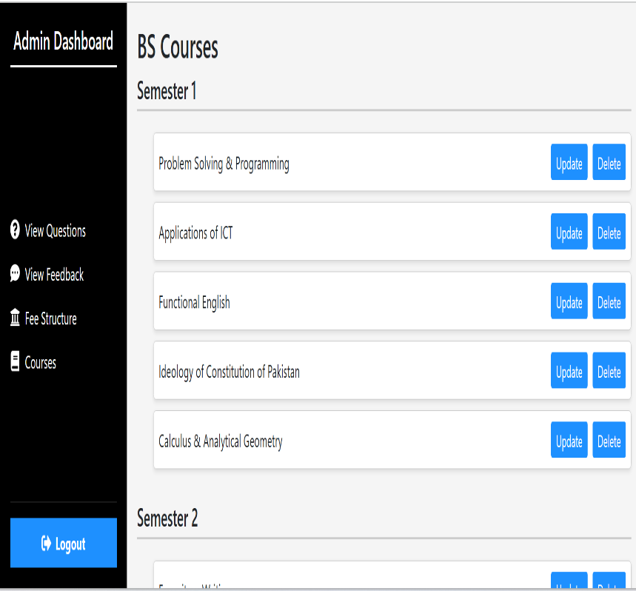
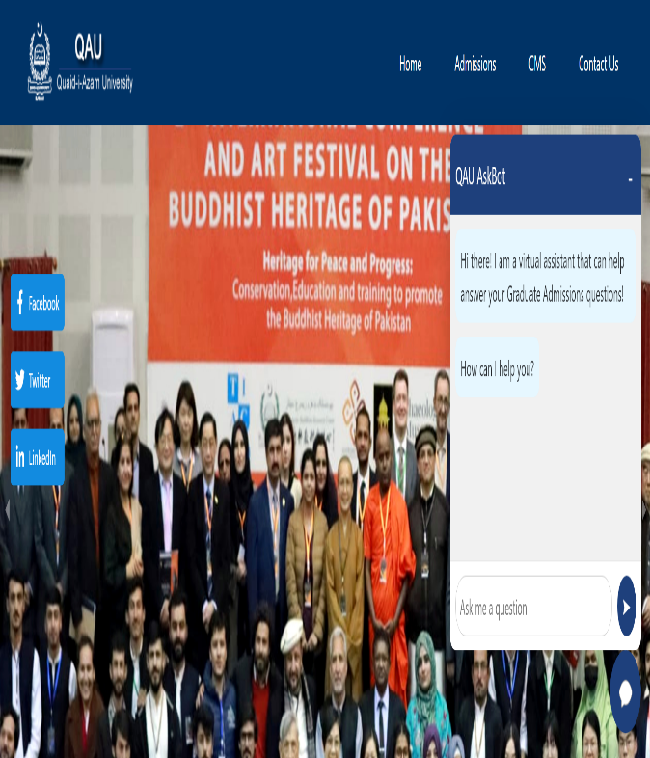

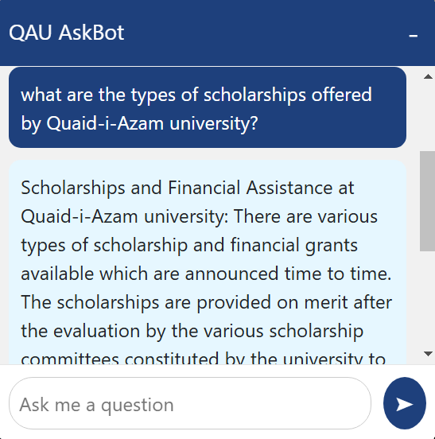

CHAPTER 5:
SOFTWARE TEST
DOCUMENTATION
(STD)

5.1 Introduction
This chapter involves the testing of the software to ensure that the system is working correctly and fixing the bugs in case of any error so that the system runs smoothly and meets the requirements. To ensure the correctness we will develop testcases and validate the performance of the system.

5.1.1 System Overview
The system that we need to test is an education related question answering system that is designed to answer the queries of the users in real time. The system uses the NLP techniques to generate answers to the questions.

5.1.2 Test Approach
We will develop test cases for each usecase and check if the system is working as expected or not.

5.2 Test Plan

5.2.1 Features to be tested
The features that need to be tested are:
- Login.
- Ask questions.
- Provide feedback.
- View questions.
- View feedback.
- Add courses.
- Delete courses.
- Update fees.
- View courses.
- View fees.

5.3 Test Cases

Test Case TC-1 | Login
Description | Verifies the functionality of login feature.
Setup | Admin has active internet connection.
Instructions | - Enter valid name and password.  - Click on the login button.
Expected results | Admin is successfully logged in to the system and the interface is displayed.
Verdict Pass/Fail | Pass

Test Case TC-2 | Ask questions
Description | User can ask a question.
Setup | User opens the QA system from the website.
Instructions | - User opens the QA system  - Enters the content of the question.  - Submits the question.
Expected results | The question is saved in the database and the system generates a response to the question.
Verdict Pass/Fail | Pass

Test Case TC-3 | Provide feedback
Description | Verifies if the user provided the feedback correctly.
Setup | User has received the response from the system.
Instructions | - User views the response generated by the system.  - Gives feedback to the response.
Expected results | The feedback of the user is saved in the database.
Verdict Pass/Fail | Pass

Test Case TC-4 | View questions
Description | Verifies if the user views the list of questions.
Setup | Admin is logged in to the system.
Instructions | - Select the view questions option from the interface.  - System retrieves the list of questions from the database.
Expected results | Admin can traverse through the list of questions.
Verdict Pass/Fail | Pass

Test Case TC-5 | View feedback
Description | Verifies if the admin views feedback provided by the user.
Setup | Admin is logged in to the system.
Instructions | - Select the view feedback option from the interface.  - System retrieves the list of feedback from the database.
Expected results | Admin can traverse through the list of responses and their associate feedback.
Verdict Pass/Fail | Pass

Test Case TC-6 | Add courses
Description | Verifies if the courses are added by the admin and displayed on the website.
Setup | Admin is logged in to the system.
Instructions | - Select the add course option from the interface.  - Enter the course details.  - Add the course.
Expected results | The course is stored in the database and displayed on the website.
Verdict Pass/Fail | Pass

Test Case TC-7 | Delete courses
Description | Verifies if the courses are deleted by the admin and updated list is displayed on the website.
Setup | Admin is logged in to the system.
Instructions | - Select the delete course option from the interface.  - Choose the course to delete.  - Confirm the deletion process.
Expected results | The course is deleted, and the list of courses is updated
Verdict Pass/Fail | Pass

Test Case TC-8 | Update fee
Description | Verifies if the admin updates the fees for different programs correctly.
Setup | Admin is logged in to the system.
Instructions | - Select the update fees option from the interface.  - Enter the new amount.  - Update the fees.
Expected results | The fees I updated and displayed on the website.
Verdict Pass/Fail | Pass

Test Case TC-9 | View courses
Description | User views the list of courses
Setup | User opens the QA system.
Instructions | - Browse through the website.  - Visit the section displaying the courses.  - View the list of courses.
Expected results | User can view the list of courses.
Verdict Pass/Fail | Pass

Test Case TC-10 | View fees
Description | User views the fees for different programs
Setup | User opens the QA system.
Instructions | - Browse through the website.  - Visit the section displaying the fees for different programs.
Expected results | User can view the fees for the specified program.
Verdict Pass/Fail | Pass

CHAPTER 6:
CONCLUSION

6.1 Conclusion
In this project we successfully developed a Question Answering system that is designed to answer the admission related questions for Quaid-i-Azam university. We used web crawling to gather the relevant information from the website and text processing like tokenization, stop words removal and lemmatization is applied to the data. After that the knowledge base is created using the inverted index containing the keywords that helps the system to quickly find the answer. It ranks the answers using cosine similarity so the users can get the relevant answers.
So by summarizing the content, the system focuses on answering users queries so the user do not have to browse the entire website to get the relevant information hence saving their time.

6.2 Future Work
In future we can improve the system by connecting it with advanced language models like Retrieval Augmented Generation (RAG) technique. By combining it with our knowledge base, the system can generate more accurate answers. Instead of the predefined answers, the LLM will retrieve and generate answer that will better address the user queries. This will allow the system to handle more complex questions. It can understand the queries better and generate more natural answers like how a human would respond to. This can improve the quality of the responses.

References:
- Software Engineering, A Practitioners Approach by Rogers Pressman, 7th Edition.
- IEEE Std 830-1998 (Revision of IEEE Std 830-1993), IEEE Recommended Practice for Software Requirements Specifications.
- Modern Information Retrieval by Ricardo Baeza-Yates and Berthier Ribeiro-Neto, 2nd Edition.

